Complex Order Processing

From PAR
Test Plan

Wege Kifle
ITG
Table of Contents

Test Setting 4
Incoming Complex Order from PAR with T/A 5
Test Case 1. Verify that incoming Complex order is rejected back to PAR when Leg has only Manual Quote resting. 5
Test Case 2. Verify that incoming Complex order is rejected back to PAR when Leg has Manual Quote aggregated with AON Customer order & Quote 5
Test Case 3. Verify that incoming Complex order trades with a resting Complex order while Manual Quote is resting on Legs, Remaining order is routed back to PAR if is becomes marketable with Manual Quote on the Top of the Book; aggregated with Quote or aggregated with Non-Customer order 6
Test Case 4. Verify that incoming Complex order trades Only with Customer order on legs when Manual Quote is aggregated with Customer order 8
Test Case 5. Verify that incoming Complex order trades with legs while Manual Quote is resting on the opposite side of the marketable legs, the remaining is routed back to PAR 10
Test Case 6. Verify that Auto Ex is not applied on incoming Complex Customer Order trading against Complex I-order and Spread Quote 10
Test Case 7. Incoming Complex order trades with resting Complex I-Order and the remaining qty trades with resting leg quotes. Verify that Auto Ex is applied for the remaining Complex order when trading with leg quote 11
Test Case 8.Verify that Incoming Complex Order trades only with leg Customer Order when Auto Ex size is set to Zero on leg, remaining Complex order is routed back to PAR 12
Test Case 9. Incoming Complex order is marketable against Leg Quotes 15
Test Case 10. Incoming Complex order is marketable against Leg Customer order only, Verify that Complex order trades with leg orders and remaining qty is routed back to PAR 18
Test Case 11. Incoming Complex order is marketable against Leg Quote and Customer Order 19
Test Case 12. Incoming Complex order is marketable against Leg Quote and Non Customer Order, Verify that order trades with leg orders and quote up to the Auto ex size at each price point 21
Complex Order Auto-Ex with Various Ratios 23
Test Case 13. Complex Product with various ratios; Verify Auto Ex against Legs 23
Incoming Complex Order From Par with Auction 27
Test Case 14. Incoming Manual Quote on leg product during COA; Verify that Auction is forced to expire if Manual Quote is accepted, Verity that Auto Ex is not applied to Auction Orders after auction is expired 27
Test Case 15. Manual Quote is resting on leg product; Verify that COA will not start for incoming Complex Order 35
APPENDIX A: 41

Test Setting

Trading Property setting to start Complex Order Auction (COA)
- Auction Enabled to TRUE for auction type Strategy (2), unless specified in the test case
- Auction Min Max Order Size to 1(lower limit) and 10000(upper limit)
- Auction Min Number Of Quoters to 1
- Auction Min Price Increment to 1
- Allow Market order is TRUE
- Auction Minimum Order Size For Ticks Above NBBO to 1 for AIM (1), HAL (4) & SAL (5)
- Auction Order Ticks Away From NBBO to 1 for HAL (4), SAL (5), & AIM (1):
- Auction Receiver Type to 1-ClassQuoter
- Auction Time To Live to value that will be long enough to execute your test events before auction expires for COA
- Auto Ex Size Against Non Customer to 9999999: (unless specified in the test case)
- Index Hybrid Indicator is set to TRUE for your OPTION class: (unless specified in the test case)
- Manual Quote Cancel Timer For PAR long enough to execute your test events before timer expires: (unless specified in the test case)
- Manual Quote Cancel Timer For Non PAR long enough to execute your test events before timer expires: (unless specified in the test case)

- Make sure that ALL MMs are subscribed for auction in order to enter RFPs and to participate in the Auction.
- Make sure the order book for the product is empty before testing each Test Cases/Scenarios.
- Make sure system is connected to TPF & your Class is Enabled for Index Hybrid From TPF

NOTE: Before executing each test cases, clear the current market; cancel any orders with remaining quantity on the legs and the spread product.

Incoming Complex Order from PAR with T/A

- Set Trading Property Auto-Ex size against non-Customer = 40 for Option class
- Verify that each Complex order Entered from SBT using Origin Code ‘D’ or ‘F’ is routed to PAR first

Test Case 1 Verify that incoming Complex order is rejected back to PAR when Leg has only Manual Quote resting.

- Leg 1: Send Manual Quote: Bid 100 x 1.00 & Offer 100 x 1.20
- Leg 2, Send Manual Quote: Bid 100 x 1.00 & Offer 100 x 1.20
- Verify Spread product is Open
- CUST1 Enters Complex Order ‘D’: Same 60@0.20 (Debit)
- CUST2 Enters Complex Order ‘D’: Same 100@MKT
- CUST3 Enters Complex IOC Order ‘D’: Opposite 60@0.10 (Debit)
- Send THE ABOVE Complex orders from PAR to SBT using T/A
Result:
  - Verify that all orders are routed back to PAR,
    - Verify Current Market Leg 1: 1.00 x 100 – 1.20 x 100
    - Verify Current Market Leg 2: 1.00 x 100 – 1.20 x 100
    - Verify Current Market Spread Product: 0.00 x 0 – 0.00 x 0

Test Case 2 Verify that incoming Complex order is rejected back to PAR when Leg has Manual Quote aggregated with AON Customer order & Quote

- Leg 1, MM1 Enters Quote: 1.00 x 100 – 1.30 x 100
- Leg 2, MM1 Enters Quote: 1.00 x 100 – 1.30 x 100
- Leg 2, Send Manual Quote: Offer 50 x 1.30
- Leg 2, CUST1 Enters ‘C’ AON Order: Sell 30@1.30
  - Current Market Leg 1: 1.00 x 100 – 1.30 x 100
  - Current Market Leg 2: 1.00 x 100 – 1.30 x 180
- CUST2 Enters Complex Order ‘D’: Opposite 60@0.30 (Debit)
- CUST2 Enters Complex Order ‘D’: Opposite 100@MKT
- CUST4 Enters Complex IOC Order ‘D’: Opposite 60@0.30 (Debit)
- Send THE ABOVE Complex orders from PAR to SBT using T/A
Result:
- Complex order is marketable against the resting manual quote on the leg.
- Verify that orders are routed back to PAR
    - Verify Current Market Leg 1: 1.00 x 100 – 1.30 x 100
          - Verify Current Market Leg 2: 1.00 x 100 – 1.30 x 180
          - Verify Current Market Spread Product: 0.00 x 0 – 0.00 x 0

Test Case 3 Verify that incoming Complex order trades with a resting Complex order while Manual Quote is resting on Legs, Remaining order is routed back to PAR if is becomes marketable with Manual Quote on the Top of the Book; aggregated with Quote or aggregated with Non-Customer order

Only Manual Quotes are resting on legs; complex order is not marketable with legs, Verify that order trades with resting Complex order and the remaining is routed back to PAR

- Leg 1: Send Manual Quote: Bid 100 x 1.00 & Offer 100 x 1.20
- Leg 2, Send Manual Quote: Bid 100 x 1.00 & Offer 100 x 1.20
  - Current Market Leg 1: 1.00 x 100 – 1.20 x 100
  - Current Market Leg 2: 1.00 x 100 – 1.20 x 100
- CUST1 Enters Complex Order ‘C’: Same 60@0.05 (credit), order is booked
- CUST2 Enters Complex Order ‘D’: Opposite 100@0.10 (debit)
- Send CUST2’s Complex order from PAR to SBT using T/A
Result:
- CUST2 order is marketable against the resting CUST1 order, Order trades 60@0.05, the remaining CUST2 40 order is routed back to PAR
    - Verify Current Market Leg 1: 1.00 x 100 – 1.20 x 100
          - Verify Current Market Leg 2: 1.00 x 100 – 1.20 x 100
          - Verify Current Market Spread Product: 0.00 x 0 – 0.00 x 0

Manual Quote is resting on Top of the Market; complex order is not marketable with legs, Verify that order trades with resting Complex order and the remaining is routed back to PAR

- Leg 1, MM1 Enters Quote: 1.00 x 100 – 1.30 x 100
- Leg 2, MM1 Enters Quote: 1.00 x 100 – 1.30 x 100
- Leg 1, Send Manual Quote: Bid 15 x 1.10
  - Current Market Leg 1: 1.10 x 15 – 1.30 x 100
  - Current Market Leg 2: 1.00 x 100 – 1.30 x 100
- CUST1 Enters Complex Order ‘C’: Same 60@0.05 (credit), order is booked
- CUST2 Enters Complex Order ‘D’: Opposite 100@0.10 (debit)
- Send CUST2’s Complex order from PAR to SBT using T/A
Result:
- CUST2 order is marketable against the resting CUST1 order, Order trades 60@0.05, the remaining CUST2 40 order is routed back to PAR
    - Verify Current Market Leg 1: 1.10 x 15 – 1.30 x 100
          - Verify Current Market Leg 2: 1.00 x 100 – 1.30 x 100
          - Verify Current Market Spread Product: 0.00 x 0 – 0.00 x 0

Manual Quote is aggregated with quote; complex order is marketable with complex order & legs, Verify that order trades with resting Complex order and the remaining is routed back to PAR

- Leg1, MM1 Enters Quote: 1.00 x 100 – 1.20 x 100
- Leg2, MM1 Enters Quote: 1.00 x 100 – 1.20 x 100
- Leg 1, Send Manual Quote: Bid 15 x 1.00
  - Current Market Leg 1: 1.00 x 115 – 1.20 x 100
  - Current Market Leg 2: 1.00 x 100 – 1.20 x 100
- CUST1 Enters Complex ‘C’ Order: Same 50@0.10 (debit)
- CUST2 Enters Complex ‘D’ order: Opposite 100@0.20 (debit)
- Send CUST2’s Complex order from PAR to SBT using T/A
Result:
  - CUST2 order trades with CUST1 Complex order 50@0.10
  - The remaining 50 order qty is routed back to PAR
    - Verify Current Market Leg 1: 1.00 x 115 – 1.20 x 100
    - Verify Current Market Leg 2: 1.00 x 100 – 1.20 x 100
    - Verify Current Market Complex Product: 0.00 x 0 – 0.00 x 0

Manual Quote is aggregated with non-Customer Order; Verify that complex order is routed back to PAR

- Leg 1, MM1 Enters Quote: 1.00 x 100 – 1.30 x 100
- Leg 2, MM1 Enters Quote: 1.00 x 100 – 1.30 x 100
- Leg 2, Send Manual Quote: Offer 15 x 1.25
- Leg 2, MM2 Enters ‘M’ ‘L’ Order: Sell 50@1.25
- Leg 2, CUST1 Enters ‘C’ Order: Sell 30@1.30
  - Current Market Leg 1: 1.00 x 100 – 1.30 x 100
  - Current Market Leg 2: 1.00 x 100 – 1.25 x 65
- CUST2 Enters Complex Order ‘D’: Opposite 100@0.30 (Debit)
- CUST3 Enters Complex Order ‘D’: Opposite 100@MKT
- CUST4 Enters Complex IOC Order ‘D’: Opposite 100@0.30 (Debit)
- Send ALL THE ABOVE Complex orders from PAR to SBT using T/A
Result:
- Complex orders are marketable against the resting manual quote on the leg. Verify that orders are routed back to PAR
    - Verify Current Market Leg 1: 1.00 x 100 – 1.30 x 100
    - Verify Current Market Leg 2: 1.00 x 100 – 1.25 x 65

Manual Quote is aggregated with non-Customer Order & quote; Verify that complex order is routed back to PAR

- Leg 1, MM1 Enters Quote: 1.00 x 100 – 1.30 x 100
- Leg 2, MM1 Enters Quote: 1.00 x 100 – 1.30 x 100
- Leg 2, Send Manual Quote: Offer 15 x 1.30
- Leg 2, MM2 Enters ‘M’ ‘L’ Order: Sell 50@1.30
  - Current Market Leg 1: 1.00 x 100 – 1.30 x 100
  - Current Market Leg 2: 1.00 x 100 – 1.30 x 165
- CUST2 Enters Complex Order ‘D’: Opposite 100@0.30 (Debit)
- CUST3 Enters Complex Order ‘D’: Opposite 100@MKT
- CUST4 Enters Complex IOC Order ‘D’: Opposite 100@0.30 (Debit)
- Send ALL THE ABOVE Complex orders from PAR to SBT using T/A
Result:
- Complex order is marketable against the resting manual quote on the leg. Verify that orders are routed back to PAR
    - Verify Current Market Leg 1: 1.00 x 100 – 1.30 x 100
    - Verify Current Market Leg 2: 1.00 x 100 – 1.30 x 165

Test Case 4 Verify that incoming Complex order trades Only with Customer order on legs when Manual Quote is aggregated with Customer order
Verify Trading Property Auto-Ex size against non-Customer = 40 for Option class

Manual Quote is aggregated with Customer Order; complex order is marketable with complex order & legs, Verify that order trades with resting Complex order & Leg order and the remaining is routed back to PAR

- Leg1, MM1 Enters Quote: 1.00 x 100 – 1.20 x 100
- Leg2, MM1 Enters Quote: 1.00 x 100 – 1.20 x 100
- Leg 1, Send Manual Quote: Bid 15 x 1.10
- Leg 1, CUST1 Enters ‘C’ Order: Buy55 x 1.10
  - Current Market Leg 1: 1.10 x 70 – 1.20 x 100
  - Current Market Leg 2: 1.00 x 100 – 1.20 x 100
- CUST2 Enters Complex ‘C’ Order: Same 50@0.10 (debit), order is booked
- CUST3 Enters Complex ‘D’ order: Opposite 100@0.20 (debit)
- Send CUST3’s Complex order from PAR to SBT using T/A
Result:
  - CUST3 order trades with CUST2 Complex order 50@0.10 & with CUST1 order 40@1.10 & Leg2 Quote 40@1.20,
  - The remaining 10 order qty is routed back to PAR
    - Verify Current Market Leg 1: 1.10 x 30 – 1.20 x 100
    - Verify Current Market Leg 2: 1.00 x 100 – 1.20 x 60
    - Verify Current Market Complex Product: 0.00 x 0 – 0.00 x 0

Manual Quote is aggregated with Quote & Customer Order; complex order is marketable with complex order & legs, Verify that order trades with resting Complex order & Leg order and the remaining is routed back to PAR

- Leg1, MM1 Enters Quote: 1.00 x 100 – 1.20 x 100
- Leg2, MM1 Enters Quote: 1.00 x 100 – 1.20 x 100
- Leg 1, Send Manual Quote: Bid 15 x 1.00
- Leg 1, CUST1 Enters ‘C’ Order: Buy 15 x 1.00
  - Current Market Leg 1: 1.00 x 130 – 1.20 x 100
  - Current Market Leg 2: 1.00 x 100 – 1.20 x 100
- CUST2 Enters Complex ‘C’ Order: Same 50@0.10 (debit), order is booked
- CUST3 Enters Complex ‘D’ order: Opposite 100@0.20 (debit)
- Send CUST3’s Complex order from PAR to SBT using T/A
Result:
  - CUST3 order trades with CUST2 Complex order 50@0.10 & with CUST1 order 15@1.00 & Leg2 Quote 15@1.20,
  - The remaining 35 order qty is routed back to PAR
    - Verify Current Market Leg 1: 1.00 x 115– 1.20 x 100
    - Verify Current Market Leg 2: 1.00 x 100 – 1.20 x 85
    - Verify Current Market Complex Product: 0.00 x 0 – 0.00 x 0

Manual Quote is aggregated with Quote and Customer Order on both legs; Verify that complex order trades with leg orders ONLY & the remaining is routed back to PAR

- Leg 1, MM1 Enters Quote: 1.00 x 100 – 1.25 x 100
- Leg 2, MM1 Enters Quote: 1.00 x 100 – 1.25 x 100
- Leg 1, Send Manual Quote: Bid 55 x 1.00
- Leg 2, Send Manual Quote: Offer 15 x 1.25
- Leg 2, CUST1 Enters ‘C’ order: Sell 35@1.25
- Leg 1, CUST2 Enters ‘C’ order: Buy 30@1.00
  - Current Market Leg 1: 1.00 x 185 – 1.25 x 100
  - Current Market Leg 2: 1.00 x 100 – 1.25 x 150
- CUST3 Enters Complex IOC Order ‘D’: Opposite 100@0.25 (Debit)
- Send CUST3’s Complex order from PAR to SBT using T/A
Result:
- CUST3 Complex order trades with Leg1 order 30@1.00 and Leg2 order 30@1.25
- The remaining 70 complex order qty is routed back to PAR
    - Verify Current Market Leg 1: 1.00 x 155 – 1.25 x 100
    - Verify Current Market Leg 2: 1.00 x 100 – 1.25 x 120

Test Case 5 Verify that incoming Complex order trades with legs while Manual Quote is resting on the opposite side of the marketable legs, the remaining is routed back to PAR

- Leg 1, MM1 Enters Quote: 1.00 x 100 – 1.20 x 100
- Leg 2, MM1 Enters Quote: 1.00 x 100 – 1.10 x 100
- Leg 1, Send Manual Quote: Offer 25 x 1.10
  - Current Market Leg 1: 1.00 x 100 – 1.10 x 25
  - Current Market Leg 2: 1.00 x 100 – 1.10 x 100
- CUST1 Enters Complex Order ‘D’: Opposite 60@0.10 (Debit)
- CUST2 Enters Complex IOC Order ‘D’: Opposite 80@0.10 (Debit)
- Send Both Complex orders from PAR to SBT using T/A
Result:
- CUST1’s Complex order trades with Leg1 quote 40@1.00 and Leg2 Quote 40@1.10 the remaining 20 is routed back to PAR
- CUST2’s Complex order trade with Leg1 quote 40@1.00 and Leg2 Quote 40@1.10, the remaining 40 is routed back to PAR
- Manual Quote remains Booked
    - Verify Current Market Leg 1: 1.00 x 20 – 1.10 x 25
    - Verify Current Market Leg 2: 1.00 x 100 – 1.10 x 20

Test Case 6 Verify that Auto Ex is not applied on incoming Complex Customer Order trading against Complex I-order and Spread Quote

- Set Trading Property Index Hybrid Indicator to TRUE for Option Classes
- Set Trading Property Auto-Ex size against non-Customer = 0 for Option Classes

Incoming Complex order trades partially with resting Spread Quote & the remaining is routed back to PAR

- Leg1, MM1 Enters Quote: 1.00 x 100 – 1.20 x 100
- Leg2, MM1 Enters Quote: 1.00 x 100 – 1.20 x 100
- MM1 Enters Spread Quote: 50 x –0.10 – 50 x 0.30
  - Verify Current Market: -0.10 x 50 – 0.30 x 50
- CUST1 Enters Complex ‘D’ order: Opposite 100@0.10 (Credit)
- Send CUST1’s Complex order from PAR to SBT using T/A
Result:
  - CUST1 order trades with Complex Quote 50@0.10
  - The remaining 50 order qty is routed back to PAR
  - Verify Current Market, Leg 1: 1.00 x 100 – 1.20 x 100
  - Verify Current Market, Leg 2: 1.00 x 100 – 1.20 x 100
  - Verify Current Market Complex Product: 0.00 x 0 – 0.00 x 0

Incoming Complex order trades partially with resting Complex I-Order & the remaining is routed back to PAR

- Leg1, MM1 Enters Quote: 1.00 x 100 – 1.20 x 100
- Leg2, MM1 Enters Quote: 1.00 x 100 – 1.20 x 100
- MM2 Enters Complex ‘I’ Order: Same 50@0.10 (debit), order is booked
  - Verify that Complex Order is booked. Current Market: -0.10 x 100 – 0.00 x 0
- CUST1 Enters Complex IOC ‘D’ order: Opposite 100@0.10 (Credit)
- Send CUST1’s Complex order from PAR to SBT using T/A
Result:
  - CUST1 order trades with Complex I order 50@0.10, the remaining 50 is routed back to PAR
  - Verify Current Market, Leg 1: 1.00 x 100 – 1.20x 100
  - Verify Current Market, Leg 2: 1.00 x 100 – 1.20x 100
  - Verify Current Market Complex Product: 0.00 x 0 – 0.00 x 0

Test Case 7 Incoming Complex order trades with resting Complex I-Order and the remaining qty trades with resting leg quotes. Verify that Auto Ex is applied for the remaining Complex order when trading with leg quote
- Set Trading Property Auto-Ex size against non-Customer = 30 for Option Classes

1)
- Leg1, MM1 Enters Quote: 1.00 x 100 – 1.20 x 100
- Leg2, MM1 Enters Quote: 1.00 x 100 – 1.20 x 100
- MM2 Enters Complex ‘I’ Order: Same 50@0.10 (debit), order is booked
- CUST1 Enters Complex ‘D’ order: Opposite 100@MKT
- Send CUST1’s Complex order from PAR to SBT using T/A
Result:
  - CUST1 order trades with Complex I order 50@0.10, Leg1 quote 30@1.00 & Leg2 quote 30@1.20
  - The remaining 20 order qty is routed back to PAR
  - Verify Current Market, Leg 1: 1.00 x 70 – 1.20 x 100
  - Verify Current Market, Leg 2: 1.00 x 100 – 1.20 x 70
  - Verify Current Market Complex Product: 0.00 x 0 – 0.00 x 0

2)
- Leg1, MM1 Enters Quote: 1.00 x 100 – 1.20 x 100
- Leg2, MM1 Enters Quote: 1.00 x 100 – 1.20 x 100
- MM2 Enters Complex ‘I’ Order: Same 50@0.10 (debit), order is booked
- CUST1 Enters Complex IOC ‘D’ order: Opposite 100@0.20, (debit)
- Send CUST1’s Complex order from PAR to SBT using T/A
Result:
  - CUST1 order trades with Complex I order 50@0.10, Leg1 quote 30@1.00 & Leg2 quote 30@1.20
  - The remaining 20 order qty is routed back to PAR
  - Verify Current Market, Leg 1: 1.00 x 70 – 1.20 x 100
  - Verify Current Market, Leg 2: 1.00 x 100 – 1.20 x 70
  - Verify Current Market Complex Product: 0.00 x 0 – 0.00 x 0

Test Case 8Verify that Incoming Complex Order trades only with leg Customer Order when Auto Ex size is set to Zero on leg, remaining Complex order is routed back to PAR

- Set Trading Property Auto-Ex size against non-Customer = 0 for Option Class

Leg has no resting customer order; Verify that incoming Complex order is routed back to PAR

- Leg1, MM1 Enters Quote: 1.00 x 100 – 1.25 x 100
- Leg2, MM1 Enters Quote: 1.00 x 100 – 1.25 x 100
- CUST1 Enters Complex Order ‘D’: Opposite 100@0.30 (Debit)
- CUST2 Enters Complex IOC Order ‘D’: Opposite 50@0.30 (Debit)
- CUST3 Enters Complex Order ‘D’: Same 100@MKT
- CUST4 Enters Complex Order ‘D’: Opposite 10@0.10 (Debit)
- CUST5 Enters Complex IOC Order ‘D’: Opposite 50@0.10 (Debit)
- Send THE ABOVE Complex orders from PAR to SBT using T/A
Result:
  - Verify that ALL Complex orders are routed back to PAR
  - Verify Current Market Leg1: 1.00 x 100 – 1.25 x 100
  - Verify Current Market Leg2: 1.00 x 100 – 1.25 x 100

Leg has resting customer order on one leg; Verify that incoming complex order is routed back to PAR

- Leg1, MM1 Enters Quote: 1.00 x 100 – 1.20 x 100
- Leg2, MM1 Enters Quote: 1.00 x 100 – 1.20 x 100
- Leg2 CUST1 Enters Order ‘C’: Buy 50@1.10
  - Current Market Leg 1: 1.00 x 100 – 1.20 x 100
  - Current Market Leg 2: 1.10 x 50 – 1.20 x 100
- CUST2 Enters Complex Order ‘D’: Same 100@MKT
- CUST3 Enters Complex IOC order ‘D’ Same 50@0.10 (Debit)
- Send THE ABOVE Complex orders from PAR to SBT using T/A
Result:
  - Verify that CUST2’s and CUST3’s orders are routed back to PAR
  - Verify Current Market Leg 1: 1.00 x 100 – 1.20 x 100
  - Verify Current Market Leg 2: 1.10 x 50 – 1.20 x 100

Leg has resting customer order on both legs; Verify that incoming complex order trades only with Customer order & remaining is routed back to PAR

- Leg1, MM1 Enters Quote: 1.00 x 100 – 1.20 x 100
- Leg2, MM1 Enters Quote: 1.00 x 100 – 1.20 x 100
- Leg2 CUST1 Enters Order ‘C’: Buy 50@1.00
- Leg1 CUST2 Enters Order ‘C’: Sell 30@1.15
  - Current Market Leg 1: 1.00 x 100 – 1.15 x 30
  - Current Market Leg 2: 1.00 x 150 – 1.20 x 100
- CUST3 Enters Complex Order ‘D’: Same 100@0.15 (Debit)
- Send CUST3’s Complex order from PAR to SBT using T/A
Result:
  - CUST3’s order trades with CUST1’s order 30@1.00 and CUST2’s order 30@1.15, the remaining 70 is routed back to PAR
  - Verify Current Market Leg 1: 1.00 x 100 – 1.20 x 100
  - Verify Current Market Leg 2: 1.00 x 120 – 1.20 x 100

- Leg1 CUST2 Enters Order ‘C’: Sell 30@1.15
  - Verify Current Market Leg 1: 1.00 x 100 – 1.15 x 30
  - Verify Current Market Leg 2: 1.00 x 120 – 1.20 x 100
- Re-Send CUST3’s Complex order from PAR to SBT using T/A
Result:
  - CUST3’s order trades with CUST1’s order 20@1.00 and CUST2’s order 20@1.15, the remaining 50 is routed back to PAR
  - Verify Current Market Leg 1: 1.00 x 100 – 1.15 x 10
  - Verify Current Market Leg 2: 1.00 x 100 – 1.20 x 100
- Leg2 CUST1 Enters Order ‘C’: Buy 50@1.00
  - Current Market Leg 1: 1.00 x 100 – 1.15 x 10
  - Current Market Leg 2: 1.00 x 150 – 1.20 x 100
- Re-Send CUST3’s Complex order from PAR to SBT using T/A
Result:
  - CUST3’s order trades with CUST1’s order 10@1.00 and CUST2’s order 10@1.15, the remaining 40 is routed back to PAR
  - Verify Current Market Leg 1: 1.00 x 100 – 1.20 x 100
  - Verify Current Market Leg 2: 1.00 x 140 – 1.20 x 100
- Leg1 CUST2 Enters Order ‘C’: Sell 50@1.15
  - Current Market Leg 1: 1.00 x 100 – 1.15 x 50
  - Current Market Leg 2: 1.00 x 140 – 1.20 x 100
- Re-Send CUST3’s Complex order from PAR to SBT using T/A
Result:
  - CUST3’s order trades with CUST1’s order 40@1.00 and CUST2’s order 40@1.15
  - Current Market Leg 1: 1.00 x 100 – 1.15 x 10
  - Current Market Leg 2: 1.00 x 100 – 1.20 x 100

Leg has resting Non-customer order only, Verify that order is routed back to TPF

- Leg1, MM1 Enters Quote: 1.00 x 100 – 1.20 x 100
- Leg2, MM1 Enters Quote: 1.00 x 100 – 1.20 x 100
- Leg1, MM2 Enters ‘M’ ‘L’ Order: Buy 15@1.15
- Leg2, MM3 Enters ‘M’ ‘L’ Order: Sell 25@1.10
- Leg1, MM4 Enters ‘M’ ‘L’ Order: Buy 50@1.05
    - Current Market Leg 1: 1.15 x 15 – 1.20 x 100
    - Current Market Leg 2: 1.00 x 100 – 1.10 x 25
- CUST1 Enters Complex IOC Order ‘D’: Opposite 10@0.20 (Debit)
- CUST2 Enters Complex Order ‘D’: Opposite 20@MKT
- Send CUST1 & 2’s Complex orders from PAR to SBT using T/A
Result:
  - Verify that Both orders are routed back to PAR
    - Verify Current Market Leg 1: 1.15 x 15 – 1.20 x 100
    - Verify Current Market Leg 2: 1.00 x 100 – 1.10 x 25

Test Case 9 Incoming Complex order is marketable against Leg Quotes

Quote qty is more than auto ex size on both legs, verify that order trades with quote and remaining is routed back to PAR
    - Set Trading Property AutoExSizeAgainstNonCustomer to 20 for Option class

- Leg1, MM1 Enters Quote: 1.00 x 100 – 1.20 x 100
- Leg2, MM1 Enters Quote: 1.10 x 100 – 1.20 x 100
- CUST1 Enters Complex Order ‘D’: Same 70@0.10 (Debit)
- Send CUST1’s Complex order from PAR to SBT using T/A
Result:
- CUST1 order trades with Leg1 quote for 20@1.20 and Leg2 quote 20@1.10
- The remaining 50 qty is routed back to PAR
  - Verify Current Market Leg1: 1.00 x 100 – 1.20 x 80
- Verify Current Market Leg2: 1.10 x 80 – 1.20 x 100
- CUST2 Enters Complex Order ‘D’: Same 80@MKT (Debit)
- Send CUST2’s Complex order from PAR to SBT using T/A
Result:
- CUST2 order trades with Leg1 quote for 20@1.20 and Leg2 quote 20@1.10
- The remaining 60 qty is routed back to PAR
  - Verify Current Market Leg1: 1.00 x 100 – 1.20 x 60
- Verify Current Market Leg2: 1.10 x 60 – 1.20 x 100
- CUST3 Enters Complex IOC Order ‘D’: Opposite 50@0.20 (Debit)
- Send CUST3’s Complex order from PAR to SBT using T/A
Result:
- CUST3 order trades with Leg1 quote for 20@1.00 and Leg2 quote 20@1.20
- The remaining 30 qty is routed back to PAR
  - Verify Current Market Leg1: 1.00 x 80 – 1.20 x 60
- Verify Current Market Leg2: 1.10 x 60 – 1.20 x 80

Quote qty is equal to auto ex size on one Leg and more that auto ex size on another leg, verify that order trades with quote and remaining is routed back to PAR
    - Set Trading Property AutoExSizeAgainstNonCustomer to 20 for Option class

- Leg1, MM1 Enters Quote: 1.00 x 100 – 1.20 x 100
- Leg2, MM1 Enters Quote: 1.10 x 20 – 1.20 x 20
- CUST1 Enters Complex IOC Order ‘D’: Same 70@0.10 (Debit)
- Send CUST1’s Complex order from PAR to SBT using T/A
Result:
- CUST1 order trades with Leg1 quote for 20@1.20 and Leg2 quote 20@1.10
- The remaining 50 qty is routed back to PAR
  - Verify Current Market Leg1: 1.00 x 100 – 1.20 x 80
- Verify Current Market Leg2: 0.00 x 0 – 1.20 x 100

- Leg1, MM1 Enters Quote: 1.00 x 100 – 1.20 x 100
- Leg2, MM1 Enters Quote: 1.00 x 20 – 1.20 x 20
- CUST1 Enters Complex Order ‘D’: Opposite 70@MKT
- Send CUST1’s Complex order from PAR to SBT using T/A
Result:
- CUST1 order trades with Leg1 quote for 20@1.00 and Leg2 quote 20@1.20
- The remaining 50 qty is routed back to PAR
  - Verify Current Market Leg1: 1.00 x 80 – 1.20 x 100
Verify Current Market Leg2: 1.00 x 20 – 0.00 x 0

Quote qty is equal to auto ex size on both legs, verify that order trades with quote and remaining is routed back to PAR
    - Set Trading Property AutoExSizeAgainstNonCustomer to 20 for Option class

- Leg1, MM1 Enters Quote: 1.00 x 20 – 1.20 x 20
- Leg2, MM1 Enters Quote: 1.00 x 20 – 1.20 x 20
- CUST1 Enters Complex IOC Order ‘D’: Opposite 80@0.20 (Debit)
- Send CUST1’s Complex order from PAR to SBT using T/A
Result:
- CUST1 order trades with Leg1 quote for 20@1.00 and Leg2 quote 20@1.20
- The remaining 60 qty is routed back to PAR
  - Verify Current Market Leg1: 0.00 x 0 – 1.20 x 20
- Verify Current Market Leg2: 1.00 x 20 – 0.00 x 0

- Leg1, MM1 Enters Quote: 1.00 x 20 – 1.20 x 20
- Leg2, MM1 Enters Quote: 1.00 x 20 – 1.20 x 20
- CUST1 Enters Complex Order ‘D’: Same 80@0.20 (Debit)
- Send CUST1’s Complex order from PAR to SBT using T/A
Result:
- CUST1 order trades with Leg2 quote for 20@1.00 and Leg1 quote 20@1.20
- The remaining 60 qty is routed back to PAR
  - Verify Current Market Spread product: -0.20 x 60 – 0.00 x 0
  - Verify Current Market Leg1: 0.00 x 0 – 1.20 x 20
- Verify Current Market Leg2: 1.00 x 20 – 0.00 x 0

Quote qty is less than auto ex size on both legs, verify that order trades with quote and remaining is routed back to PAR
    - Set Trading Property AutoExSizeAgainstNonCustomer to 100 for Option class

- Leg1, MM1 Enters Quote: 1.00 x 50 – 1.10 x 50
- Leg2, MM1 Enters Quote: 1.00 x 50 – 1.10 x 50
- CUST1 Enters Complex Order ‘D’: Same 100@0.10 (Debit)
- Send CUST1’s Complex order from PAR to SBT using T/A
Result:
- CUST1 order trades with Leg1 quote for 50@1.10 and Leg2 quote 50@1.10
- The remaining 50 qty is routed back to PAR
  - Verify Current Market Complex Book: 0.00 x 0 – 0.00 x 0
  - Verify Current Market Leg1: 1.00 x 50 – 0.00 x 0
  - Verify Current Market Leg2: 0.00 x 0 – 1.10 x 50

- Leg1, MM1 Enters Quote: 1.00 x 50 – 1.10 x 50
- Leg2, MM1 Enters Quote: 1.00 x 50 – 1.10 x 50
- CUST1 Enters Complex IOC Order ‘D’: Same 80@0.10 (Debit)
- Send CUST1’s Complex order from PAR to SBT using T/A
Result:
- CUST1 order trades with Leg1 quote for 50@1.10 and Leg2 quote 50@1.10
- The remaining 30 qty is routed back to PAR
  - Verify Current Market Complex Book: 0.00 x 0 – 0.00 x 0
  - Verify Current Market Leg1: 1.00 x 50 – 0.00 x 0
  - Verify Current Market Leg2: 0.00 x 0 – 1.10 x 50

- Leg1, MM1 Enters Quote: 1.00 x 50 – 1.10 x 50
- Leg2, MM1 Enters Quote: 1.00 x 50 – 1.10 x 50
- CUST1 Enters Complex Order ‘D’: Same 100@MKT
- Send CUST1’s Complex order from PAR to SBT using T/A
Result:
- CUST1 order trades with Leg1 quote for 50@1.10 and Leg2 quote 50@1.10
- The remaining 50 is routed back to PAR
  - Verify Current Market Complex Book: 0.00 x 0 – 0.00 x 0
  - Verify Current Market Leg1: 1.00 x 50 – 0.00 x 0
  - Verify Current Market Leg2: 0.00 x 0 – 1.10 x 50

Test Case 10 Incoming Complex order is marketable against Leg Customer order only, Verify that Complex order trades with leg orders and remaining qty is routed back to PAR
- Set Trading Property AutoExSizeAgainstNonCustomer is 20 for Option class

- Leg1, MM1 Enters Quote: 1.00 x 100 – 1.30 x 100
- Leg2, MM1 Enters Quote: 1.00 x 100 – 1.30 x 100
- Leg2, CUST1 Enters ‘C’ order: Sell 35@1.25
- Leg1, CUST2 Enters ‘C’ order: Buy 70@1.00
  - Current Market Leg 1: 1.00 x 170 – 1.30 x 100
  - Current Market Leg 2: 1.00 x 100 – 1.25 x 35
- CUST3 Enters Complex Order ‘D’: Opposite 50@0.25 (Debit)
- Send CUST3’s Complex order from PAR to SBT using T/A
Result:
- CUST3 order trades with CUST2 order for 35@1.00 and CUST1 order 35@1.25
- The remaining CUST3 15 order qty is routed back to PAR
  - Verify Current Market Complex Book: 0.00 x 0 – 0.00 x 0
- Verify Current Market Leg1: 1.00 x 135 – 1.30 x 100
  - Verify Current Market Leg2: 1.00 x 100 – 1.30 x 100

- Leg2, CUST1 Enters ‘C’ order: Sell 25@1.25
  - Current Market Leg 1: 1.00 x 135 – 1.30 x 100
  - Current Market Leg 2: 1.00 x 100 – 1.25 x 25
- CUST4 Enters Complex IOC Order ‘D’: Opposite 50@0.25 (Debit)
- Send CUST4’s Complex order from PAR to SBT using T/A
Result:
- CUST4 order trades with CUST2 order for 25@1.00 and CUST1 order 25@1.25
- The remaining CUST4 25 order qty is routed back to PAR
  - Verify Current Market Complex Book: 0.00 x 0 – 0.00 x 0
- Verify Current Market Leg1: 1.00 x 110 – 1.30 x 100
  - Verify Current Market Leg2: 1.00 x 100 – 1.30 x 100

Test Case 11 Incoming Complex order is marketable against Leg Quote and Customer Order
- Verify Trading Property AutoExSizeAgainstNonCustomer is 20 for Option class

Customer order is aggregated with quote on one leg and on the top of the book on another leg
Scenario 1:
- Leg1, MM1 Enters Quote: 1.00 x 100 – 1.30 x 100
- Leg2, MM1 Enters Quote: 1.00 x 100 – 1.30 x 100
- Leg2, CUST1 Enters ‘C’ order: Buy 50@1.00
- Leg1, CUST2 Enters ‘C’ order: Sell 25@1.25
  - Current Market Leg 1: 1.00 x 100 – 1.25 x 25
  - Current Market Leg 2: 1.00 x 150 – 1.30 x 100
- CUST3 Enters Complex Order ‘D’: Same 100@0.30 (Debit)
- Send CUST3’s Complex order from PAR to SBT using T/A
Result:
- CUST3 order trades with, Leg1 Sell order for 25@1.25 , Leg1 Quote for 20@1.30, & Leg2 Buy order 45@1.00
- The remaining 55 order qty is routed back to PAR
- Verify Current Market Leg1: 1.00 x 100 – 1.30 x 80
  - Verify Current Market Leg2: 1.00 x 105 – 1.30 x 100

Scenario 2:
- Leg1, MM1 Enters Quote: 1.00 x 100 – 1.30 x 100
- Leg2, MM1 Enters Quote: 1.00 x 100 – 1.30 x 100
- Leg2, CUST1 Enters ‘C’ order: Buy 10@1.00
- Leg1, CUST2 Enters ‘C’ order: Sell 25@1.25
  - Current Market Leg 1: 1.00 x 100 – 1.25 x 25
  - Current Market Leg 2: 1.00 x 110 – 1.30 x 100
- CUST3 Enters Complex IOC Order ‘D’: Same 100@0.30 (Debit)
- Send CUST3’s Complex order from PAR to SBT using T/A
Result:
- CUST3 order trades with, Leg1 Sell order for 25@1.25, Leg1 Quote for 20@1.30, Leg2 Buy order 10@1.00, & Leg2 Quote for 35@1.00
- The remaining 55 order qty is routed back to PAR
- Verify Current Market Leg1: 1.00 x 100 – 1.30 x 80
  - Verify Current Market Leg2: 1.00 x 65 – 1.30 x 100

Customer order is aggregated with quote on both legs

- Leg1, MM1 Enters Quote: 1.00 x 100 – 1.25 x 100
- Leg2, MM1 Enters Quote: 1.00 x 100 – 1.25 x 100
- Leg2, CUST1 Enters ‘C’ order: Buy 10@1.00
- Leg1, CUST2 Enters ‘C’ order: Sell 25@1.25
  - Current Market Leg 1: 1.00 x 100 – 1.25 x 125
  - Current Market Leg 2: 1.00 x 110 – 1.25 x 100
- CUST3 Enters Complex Order ‘D’: Same 100@0.25 (Debit)
- Send CUST3’s Complex order from PAR to SBT using T/A
Result:
- CUST3 order trades with
  - Leg1 Sell order for 25@1.25
  - Leg1 Quote for 5@1.25
  - Leg2 Buy order 10@1.00
  - Leg2 Quote for 20@1.00
- The remaining 70 order qty is routed back to PAR
  - Verify Current Market Complex Book: 0.00 x 0 – 0.00 x 0
- Verify Current Market Leg1: 1.00 x 100 – 1.25 x 95
  - Verify Current Market Leg2: 1.00 x 80 – 1.25 x 100

Multiple Customer orders are resting on the book at various market price, Verify that Complex order trades with quote & order and remaining qty is routed back to TPF
- Leg1, MM1 Enters Quote: 1.00 x 100 – 1.20 x 100
- Leg2, MM1 Enters Quote: 1.00 x 100 – 1.20 x 100
- Leg1, CUST1 Enters ‘C’ order: Buy 90@1.10
- Leg1, CUST2 Enters ‘C’ order: Buy 15@1.05
- Leg1, CUST3 Enters ‘C’ order: Buy 20@1.00
- Leg2, CUST4 Enters ‘C’ order: Sell 50@1.20
    - Current Market Leg 1: 1.10 x 90 – 1.20 x 100
    - Current Market Leg 2: 1.00 x 100 – 1.20 x 150
- CUST5 Enters Complex IOC Order ‘D’: Opposite 100@0.20 (Debit)
- Send CUST5’s Complex order from PAR to SBT using T/A
Result:
  - CUST5 order trades with CUST1 order for 70@1.10, Leg2 Customer order for 50@1.20, & Leg2 quote 20@1.20
  - The remaining 30 order qty is routed back to PAR
    - Verify Current Market Leg 1: 1.10 x 20 – 1.20 x 100
    - Verify Current Market Leg 2: 1.00 x 100 – 1.20 x 80
- Send CUST5’s (30) Complex order from PAR to SBT using T/A
Result:
  - CUST5 order trades with CUST1 order for 20@1.10, & Leg2 quote 20@1.20
  - The remaining 10 order qty is routed back to PAR
    - Verify Current Market Leg 1: 1.05 x 15 – 1.20 x 100
    - Verify Current Market Leg 2: 1.00 x 100 – 1.20 x 60
- CUST2 cancels order from Leg1 (15@1.05) & Enters New order on Leg2 Sell 5@1.20
    - Verify Current Market Leg 1: 1.00 x 120 – 1.20 x 100
    - Verify Current Market Leg 2: 1.00 x 100 – 1.20 x 65
- CUST5 Enters Complex Order ‘D’: Opposite 50@0.20 (Debit)
- Send CUST5’s Complex order from PAR to SBT using T/A
Result:
  - CUST5 order trades with CUST3 order for 20@1.00, Leg2 quote 20@1.20, Leg 1 quote 5@1.00 & Leg2 quote CUST2 order 5@1.20
  - The remaining 25 order qty is routed back to PAR
    - Verify Current Market Leg 1: 1.00 x 95 – 1.20 x 100
    - Verify Current Market Leg 2: 1.00 x 100 – 1.20 x 40

Test Case 12 Incoming Complex order is marketable against Leg Quote and Non Customer Order, Verify that order trades with leg orders and quote up to the Auto ex size at each price point
- Verify Trading Property AutoExSizeAgainstNonCustomer is 20 for Option class

- Complex order tradse with all resting order s

- Leg1, MM1 Enters Quote: 1.00 x 100 – 1.20 x 100
- Leg2, MM1 Enters Quote: 1.00 x 100 – 1.20 x 100
- Leg1, MM2 Enters ‘M’ ‘L’ Order: Buy 15@1.15
- Leg1, MM3 Enters ‘M’ ‘L’ Order: Buy 10@1.10
- Leg1, MM4 Enters ‘M’ ‘L’ Order: Buy 5@1.05
- Leg1, MM5 Enters ‘M’ ‘L’ Order: Buy 20@1.00
    - Current Market Leg 1: 1.15 x 15 – 1.20 x 100
    - Current Market Leg 2: 1.00 x 100 – 1.20 x 100
- CUST5 Enters Complex IOC Order ‘D’: Opposite 100@0.20 (Debit)
- Send CUST5’s Complex order from PAR to SBT using T/A
Result:
  - CUST5 order trades with MM2 order 15@1.15, MM3 order 10@1.10, MM4 order 5@1.05, MM5 order 7@1.00, Leg1 quote 13@1.00 & Leg2 quote for 50@1.20
  - The remaining 50 order qty is routed back to PAR
    - Verify Current Market Leg 1: 1.00 x 100 – 1.20 x 100
    - Verify Current Market Leg 2: 1.00 x 100 – 1.20 x 50

- Complex order trades with only one order since auto ex is reached at the 1st order price

- Leg1, MM1 Enters Quote: 1.00 x 100 – 1.20 x 100
- Leg2, MM1 Enters Quote: 1.00 x 100 – 1.20 x 100
- Leg1, MM2 Enters ‘M’ ‘L’ Order: Buy 20@1.15
- Leg1, MM3 Enters ‘M’ ‘L’ Order: Buy 15@1.10
- Leg1, MM4 Enters ‘M’ ‘L’ Order: Buy 20@1.00
    - Current Market Leg 1: 1.15 x 22 – 1.20 x 100
    - Current Market Leg 2: 1.00 x 100 – 1.20 x 100
- CUST4 Enters Complex Order ‘D’: Opposite 100@MKT
- Send CUST4’s Complex order from PAR to SBT using T/A
Result:
  - CUST4 order trades with MM2 order 20@1.15, & Leg2 quote for 20@1.20
  - The remaining 80 order qty is routed back to PAR
    - Verify Current Market Leg 1: 1.10 x 15– 1.20 x 100
    - Verify Current Market Leg 2: 1.00 x 100 – 1.20 x 80

Complex Order Auto-Ex with Various Ratios

Test Case 13 Complex Product with various ratios; Verify Auto Ex against Legs
- Set Trading Property AutoExSizeAgainstNonCustomer is 10 for Option class
- 1:2 Ratio: Leg1: Buy 1, Leg2: Sell 2

- Leg1, MM1 Enters Quote: 1.00 x 100 – 1.20 x 100
- Leg2, MM1 Enters Quote: 1.00 x 100 – 1.20 x 100
- CUST1 Enters Complex Order ‘D’: Opposite 100@MKT
- Send CUST1’s Complex order from PAR to SBT using T/A
Result:
  - CUST1 order trades with Leg1 quote 5@1.00, & Leg2 quote for 10@1.20
  - The remaining 95 order qty is routed back to PAR
    - Verify Current Market Leg 1: 1.00 x 95 – 1.20 x 100
    - Verify Current Market Leg 2: 1.00 x 100 – 1.20 x 90

- SetTrading Property AutoExSizeAgainstNonCustomer is 20 for Option class
- 1:2 Ratio: Leg1: Buy 1, Leg2: Sell 2

- Leg1, MM1 Enters Quote: 1.00 x 100 – 1.20 x 100
- Leg2, MM1 Enters Quote: 1.00 x 100 – 1.20 x 100
- CUST1 Enters Complex Order ‘D’: Same 100@MKT
- Send CUST1’s Complex order from PAR to SBT using T/A
Result:
  - CUST1 order trades with Leg2 quote 20@1.00, & Leg1 quote for 10@1.20
  - The remaining 90 order qty is routed back to PAR
    - Verify Current Market Leg 1: 1.00 x 100 – 1.20 x 90
    - Verify Current Market Leg 2: 1.00 x 80 – 1.20 x 100

- 1:2:1 Ratio: Leg1: Buy 1, Leg2: Sell 2, Leg3: Buy 1

- Leg1, MM1 Enters Quote: 1.00 x 100 – 1.20 x 100
- Leg2, MM1 Enters Quote: 1.10 x 100 – 1.30 x 100
- Leg3, MM1 Enters Quote: 1.15 x 100 – 1.30 x 100
- CUST1 Enters Complex IOC Order ‘D’: Same 100@0.30 (debit)
- Send CUST1’s Complex order from PAR to SBT using T/A
Result:
  - CUST1 order trades with Leg2 quote 20@1.10, & Leg1 quote for 10@1.20, & Leg3 quote 10@1.30
  - The remaining 90 order qty is routed back to PAR
    - Verify Current Market Leg 1: 1.00 x 100 – 1.20 x 90
    - Verify Current Market Leg 2: 1.10 x 80 – 1.30 x 100
    - Verify Current Market Leg 2: 1.15 x 100 – 1.30 x 90
- CUST2 Enters Complex Order ‘D’: Same 100@0.30 (debit)
- Send CUST2’s Complex order from PAR to SBT using T/A
Result:
  - CUST2 order trades with Leg2 quote 20@1.10, & Leg1 quote for 10@1.20, & Leg3 quote 10@1.30
  - The remaining 90 order qty is routed back to PAR
    - Verify Current Market Leg 1: 1.00 x 100 – 1.20 x 80
    - Verify Current Market Leg 2: 1.10 x 60 – 1.30 x 100
    - Verify Current Market Leg 2: 1.15 x 100 – 1.30 x 80

- SetTrading Property AutoExSizeAgainstNonCustomer is 15 for Option class
- 1:1 Ratio: Leg1: Buy 1, Leg2: Sell 1

- Leg1, MM1 Enters Quote: 1.00 x 100 – 1.20 x 100
- Leg2, MM1 Enters Quote: 1.00 x 100 – 1.20 x 100
- CUST1 Enters Complex IOC Order ‘D’: Opposite 100@0.20 (debit)
- Send CUST1’s Complex order from PAR to SBT using T/A
Result:
  - CUST1 order trades with Leg1 quote 15@1.00, & Leg2 quote 15@1.20
  - The remaining 85 order qty is routed back to PAR
    - Verify Current Market Leg 1: 1.00 x 85 – 1.20 x 100
    - Verify Current Market Leg 2: 1.00 x 100 – 1.20 x 85

- 1:2:1 Ratio: Leg1: Sell 1, Leg2: Buy 2, Leg3: Sell 1

- Leg1, MM1 Enters Quote: 1.10 x 100 – 1.30 x 100
- Leg2, MM1 Enters Quote: 1.00 x 100 – 1.20 x 100
- Leg3, MM1 Enters Quote: 1.20 x 100 – 1.40 x 100
- CUST1 Enters Complex IOC Order ‘D’: Same 100@0.10 (debit)
- Send CUST1’s Complex order from PAR to SBT using T/A
Result:
  - CUST1 order trades with Leg2 quote 14@1.20, & Leg1 quote for 7@1.10, & Leg3 quote 7@1.20
  - The remaining 93 order qty is routed back to PAR
    - Verify Current Market Leg 1: 1.10 x 93 – 1.30 x 100
    - Verify Current Market Leg 2: 1.00 x 100 – 1.20 x 86
    - Verify Current Market Leg 2: 1.20 x 93 – 1.40 x 100

- CUST1 Enters Complex Order ‘D’: Same 100@0.10 (debit)
- Send CUST1’s Complex order from PAR to SBT using T/A
Result:
  - CUST1 order trades with Leg2 quote 14@1.20, & Leg1 quote for 7@1.10, & Leg3 quote 7@1.20
  - The remaining 93 order qty is routed back to PAR
    - Verify Current Market Leg 1: 1.10 x 86 – 1.30 x 100
    - Verify Current Market Leg 2: 1.00 x 100 – 1.20 x 72
    - Verify Current Market Leg 2: 1.20 x 86 – 1.40 x 100

- CUST1 Enters Complex Order ‘D’: Opposite 100@MKT
- Send CUST1’s Complex order from PAR to SBT using T/A
Result:
  - CUST1 order trades with Leg2 quote 14@1.00, & Leg1 quote for 7@1.30, & Leg3 quote 7@1.40
  - The remaining 93 order qty is routed back to PAR
    - Verify Current Market Leg 1: 1.10 x 86 – 1.30 x 93
    - Verify Current Market Leg 2: 1.00 x 86 – 1.20 x 72
    - Verify Current Market Leg 2: 1.20 x 86 – 1.40 x 93

- SetTrading Property AutoExSizeAgainstNonCustomer is 50 for Option class
- 1:2:1 Ratio: Leg1: Buy 1, Leg2: Sell 2, Leg3: Buy 1

- Leg1, MM1 Enters Quote: 1.00 x 100 – 1.20 x 100
- Leg2, MM1 Enters Quote: 1.10 x 100 – 1.30 x 100
- Leg3, MM1 Enters Quote: 1.15 x 100 – 1.25 x 100
- CUST1 Enters Complex IOC Order ‘D’: Same 100@2.15 (credit)
- Send CUST1’s Complex order from PAR to SBT using T/A
Result:
  - CUST1 order trades with Leg2 quote 50@1.10, & Leg1 quote for 25@1.20, & Leg3 quote 25@1.15
  - The remaining 75 order qty is routed back to PAR
    - Verify Current Market Leg 1: 1.00 x 100 – 1.20 x 75
    - Verify Current Market Leg 2: 1.10 x 50 – 1.30 x 100
    - Verify Current Market Leg 2: 1.15 x 75 – 1.25 x 100
- CUST2 Enters Complex Order ‘D’: Same 100@MKT
- Send CUST2’s Complex order from PAR to SBT using T/A
Result:
  - CUST2 order trades with Leg2 quote 50@1.10, & Leg1 quote for 25@1.20, & Leg3 quote 25@1.15
  - The remaining 75 order qty is routed back to PAR
    - Verify Current Market Leg 1: 1.00 x 100 – 1.20 x 50
    - Verify Current Market Leg 2: 0.00 x 0 – 1.30 x 100
    - Verify Current Market Leg 2: 1.15 x 50 – 1.25 x 100

- SetTrading Property AutoExSizeAgainstNonCustomer is 1 for Option class
- 1:1 Ratio: Leg1: Buy 1, Leg2: Sell 1

- Leg1, MM1 Enters Quote: 1.00 x 100 – 1.20 x 100
- Leg2, MM1 Enters Quote: 1.00 x 100 – 1.20 x 100
- CUST1 Enters Complex IOC Order ‘D’: Same 100@0.20 (debit)
- Send CUST1’s Complex order from PAR to SBT using T/A
Result:
  - CUST1 order trades with Leg1 quote 1@1.00, & Leg1 quote for 1@1.20
  - The remaining 99 order qty is routed back to PAR
    - Verify Current Market Leg 1: 1.00 x 100 – 1.20 x 99
    - Verify Current Market Leg 2: 1.00 x 99 – 1.20 x 100

- 2:1 Ratio: Leg1: Buy 2, Leg2: Sell 1

- Leg1, MM1 Enters Quote: 1.00 x 100 – 1.20 x 100
- Leg2, MM1 Enters Quote: 1.00 x 100 – 1.20 x 100
- CUST1 Enters Complex Order ‘D’: Same 100@MKT
- Send CUST1’s Complex order from PAR to SBT using T/A
Result:
  - CUST1 order is routed back to PAR
    - Verify Current Market Leg 1: 1.00 x 100 – 1.20 x 100
    - Verify Current Market Leg 2: 1.00 x 100 – 1.20 x 100

Incoming Complex Order From Par with Auction

- Set Trading Property Auto-Ex size against non-Customer = 0 for Option class
- The following Test Cases uses Origin Code ‘F’ for COA eligible orders
- Verify that each Complex order Entered from SBT using Origin Code ‘D’ or ‘F’ is routed to PAR first

Test Case 14 Incoming Manual Quote on leg product during COA; Verify that Auction is forced to expire if Manual Quote is accepted, Verity that Auto Ex is not applied to Auction Orders after auction is expired

Incoming Manual Quote on the marketable leg forces COA to expire; Complex Order is not marketable against the legs, Verify that Order is routed back to PAR

- Leg 1, MM1 Enters Quote: 1.00 x 100 – 1.30 x 100
- Leg 2, MM1 Enters Quote: 1.00 x 100 – 1.30 x 100
- CUST1 Enters Complex Order ‘F’: Opposite 80@0.20 (debit)
- Send CUST1’s Complex order from PAR to SBT using AUCTION
    - Auction Starts
- Leg 2, Send Manual Quote: Offer 21 x 1.25
Result:
- Manual Quote forces Auction to expire. Verify that manual quote is accepted and booked & order is routed back to PAR
  - Current Market, Leg 1: 1.00 x 100 – 1.30 x 100
  - Current Market, Leg 2: 1.00 x 100 – 1.25 x 21
- Current Market, Complex Product: 0.00 x 0 – 0.00 x 0

Incoming Manual Quote on the marketable leg forces COA to expire; Complex IOC Order is not marketable against the legs, verify that Order is canceled.

- Leg 1, MM1 Enters Quote: 1.00 x 100 – 1.30 x 100
- Leg 2, MM1 Enters Quote: 1.00 x 100 – 1.30 x 100
- CUST1 Enters Complex IOC Order ‘F’: Opposite 80@0.20 (debit)
- Send CUST1’s Complex order from PAR to SBT using AUCTION
  - Auction Starts
- Leg 2, Send Manual Quote: Offer 21 x 1.25
Result:
- Manual Quote forces Auction to expire. Verify that Manual Quote is accepted and booked & Complex IOC order is canceled.
  - Current Market, Leg 1: 1.00 x 100 – 1.30 x 100
  - Current Market, Leg 2: 1.00 x 100 – 1.25 x 21
- Current Market, Complex Product: 0.00 x 0 – 0.00 x 0

Incoming Manual Quote on the marketable leg forces COA to expire; Complex IOC Order is marketable against the resting TOP of the Book Spread Orders.

- Leg 1, MM1 Enters Quote: 1.00 x 100 – 1.30 x 100
- Leg 2, MM1 Enters Quote: 1.00 x 100 – 1.30 x 100
- CUST1 Enters Complex Order ‘C’: Opposite 20@0.10 (credit), order is booked
- CUST2 Enters Complex Order ‘C’: Opposite 30@0.05 (credit), order is booked
- CUST3 Enters Complex IOC Order ‘F’: Same 80@0.10 (debit)
- Send CUST3’s Complex order from PAR to SBT using AUCTION
  - Auction Starts
- Leg 1, Send Manual Quote: Offer 21 x 1.30
Result:
- Manual Quote forces Auction to expire. Verify that Manual Quote is accepted and booked
- CUSt3’s Complex IOC order trades with CUST1 order 20@0.10 and CUST2 order 30@0.05 the remaining 30 is canceled
  - Current Market, Leg 1: 1.00 x 100 – 1.30 x 121
  - Current Market, Leg 2: 1.00 x 100 – 1.30 x 100
- Current Market, Complex Product: 0.00 x 0 – 0.00 x 0

Incoming Manual Quote on the marketable leg forces COA to expire; Complex Order is marketable against the resting TOP of the Book Spread Quote & Spread Order.

- Leg 1, MM1 Enters Quote: 1.00 x 100 – 1.30 x 100
- Leg 2, MM1 Enters Quote: 1.00 x 100 – 1.30 x 100
- MM2 Enters Spread Quote: 0.20 x 50 – 0.10 x 10
- CUST1 Enters Complex Order ‘C’: Opposite 30@0.15 (credit), order is booked
- CUST2 Enters Complex Order ‘F’: Same 100@0.15 (debit)
- Send CUST2’s Complex order from PAR to SBT using AUCTION
  - Auction Starts
- Leg 1, Send Manual Quote: Offer 21 x 1.30
Result:
- Manual Quote forces Auction to expire. Verify that Manual Quote is accepted and booked
- Complex order trades with CUST1 order 30@0.15 and Spread Quote 50@0.10 the remaining 20 is routed back to PAR
  - Current Market, Leg 1: 1.00 x 100 – 1.30 x 121
  - Current Market, Leg 2: 1.00 x 100 – 1.30 x 100
- Current Market, Complex Product: 0.00 x 0 – 0.00 x 0

Incoming Manual Quote on the marketable leg forces COA to expire; Complex IOC Order is marketable against the resting TOP of the Book Spread Orders & The Manual Quote.

- Leg 1, MM1 Enters Quote: 1.00 x 100 – 1.30 x 100
- Leg 2, MM1 Enters Quote: 1.00 x 100 – 1.30 x 100
- CUST1 Enters Complex Order ‘C’: Opposite 20@0.10 (credit), order is booked
- CUST2 Enters Complex Order ‘C’: Opposite 30@0.05 (credit), order is booked
- CUST3 Enters Complex IOC Order ‘F’: Same 100@0.10 (debit)
- Send CUST3’s Complex order from PAR to SBT using AUCTION
  - Auction Starts
- Leg 1, Send Manual Quote: Offer 21 x 1.10
Result:
- Manual Quote forces Auction to expire. Verify that Manual Quote is accepted and booked
- Complex order trades with CUST1 order 20@0.10 and CUST2 order 30@0.05 the remaining 50 is canceled
  - Current Market, Leg 1: 1.00 x 100 – 1.10 x 21
  - Current Market, Leg 2: 1.00 x 100 – 1.30 x 100
- Current Market, Complex Product: 0.00 x 0 – 0.00 x 0

Incoming Manual Quote on the marketable leg forces COA to expire; Complex Non-Contingency Order is marketable against the resting TOP of the Book Spread Orders & The Manual Quote.

- Leg 1, MM1 Enters Quote: 1.00 x 100 – 1.30 x 100
- Leg 2, MM1 Enters Quote: 1.00 x 100 – 1.30 x 100
- CUST1 Enters Complex Order ‘C’: Opposite 20@0.10 (credit), order is booked
- CUST2 Enters Complex Order ‘C’: Opposite 30@0.05 (credit), order is booked
- CUST3 Enters Complex Order ‘F’: Same 100@0.10 (debit)
- Send CUST3’s Complex order from PAR to SBT using AUCTION
  - Auction Starts
- Leg 1, Send Manual Quote: Offer 21 x 1.10
Result:
- Manual Quote forces Auction to expire. Verify that Manual Quote is accepted and booked
- Complex order trades with CUST1 order 20@0.10 and CUST2 order 30@0.05 the remaining 50 is routed back to PAR
  - Current Market, Leg 1: 1.00 x 100 – 1.10 x 21
  - Current Market, Leg 2: 1.00 x 100 – 1.30 x 100
  - Current Market, Complex Product: 0.00 x 0 – 0.00 x 0

Incoming Manual Quote on the marketable leg forces COA to expire; Complex Order is marketable against the Manual Quote, Verify that Manual Quote is booked and order is routed back to PAR since it becomes non marketable against the legs

- Leg 1, MM1 Enters Quote: 1.00 x 100 – 1.30 x 100
- Leg 2, MM1 Enters Quote: 1.00 x 100 – 1.30 x 100
- CUST1 Enters Complex Order ‘F’: Opposite 100@0.10 (debit)
- Send CUST1’s Complex order from PAR to SBT using AUCTION
  - Auction Starts
- Leg 2, Send Manual Quote: Offer 50 x 1.10
Result:
- Manual Quote forces Auction to expire, Verify that Manual Quote is booked & order is routed back to PAR
  - Current Market, Leg 1: 1.00 x 100 – 1.30 x 100
  - Current Market, Leg 2: 1.00 x 100 – 1.10 x 50
- Current Market, Complex Product: 0.00 x 0 – 0.00 x 0

Incoming Manual Quote on the marketable leg forces COA to expire; Complex IOC Order is marketable against the Manual Quote, Verify that Manual Quote is booked and order is canceled since it becomes non marketable against the legs

- Leg 1, MM1 Enters Quote: 1.00 x 100 – 1.30 x 100
- Leg 2, MM1 Enters Quote: 1.00 x 100 – 1.30 x 100
- CUST1 Enters Complex IOC Order ‘F’: Opposite 100@0.10 (debit)
- Send CUST1’s Complex order from PAR to SBT using AUCTION
  - Auction Starts
- Leg 2, Send Manual Quote: Offer 50 x 1.10
Result:
- Manual Quote forces Auction to expire, IOC order is canceled & Manual Quote is booked
  - Current Market, Leg 1: 1.00 x 100 – 1.30 x 100
  - Current Market, Leg 2: 1.00 x 100 – 1.10 x 50
- Current Market, Complex Product: 0.00 x 0 – 0.00 x 0

Incoming Manual Quote on the marketable leg forces COA to expire; Complex Order is marketable against the Manual Quote & Auto Quote on leg

Non-Contingency Complex Order trades fully with leg quotes, Leg has remaining Qty. Verify that Manual Quote remains booked
- Leg 1, MM1 Enters Quote: 1.00 x 100 – 1.30 x 100
- Leg 2, MM1 Enters Quote: 1.00 x 100 – 1.30 x 100
- CUST1 Enters Complex Order ‘F’: Opposite 80@0.30 (debit)
- Send CUST1’s Complex order from PAR to SBT using AUCTION
  - Auction Starts
- Leg 1, Send Manual Quote: Bid 50 x 1.00
Result:
- Manual Quote forces Auction to expire, Complex order trades with Leg1 quote 80@1.00 and Leg2 quote 80@1.30
  - Manual Quote remains booked
  - Current Market, Leg 1: 1.00 x 70 – 1.30 x 100
  - Current Market, Leg 2: 1.00 x 100 – 1.30 x 20

Non-Contingency Complex Order trades Partially with leg quotes, Leg has ZERO Qty, Verify that Manual Quote is booked
- Leg 1, MM1 Enters Quote: 1.00 x 100 – 1.30 x 100
- Leg 2, MM1 Enters Quote: 1.00 x 100 – 1.30 x 100
- CUST1 Enters Complex Order ‘F’: Opposite 150@0.30 (debit)
- Send CUST1’s Complex order from PAR to SBT using AUCTION
  - Auction Starts
- Leg 1, Send Manual Quote: Bid 50 x 1.00
Result:
- Manual Quote forces Auction to expire, Complex order trades with Leg1 quote 100@1.00 and Leg2 quote 100@1.30
  - Manual Quote is booked, remaining 50 Complex order is routed back t0 PAR
  - Current Market, Leg 1: 1.00 x 50 – 1.30 x 100
  - Current Market, Leg 2: 1.00 x 100 – 0.00 x 0
  - Current Market, Spread Book: 0.00 x 0 – 0.00 x 0

Contingency IOC Complex Order trades partially with leg quotes, Verify that Manual Quote is booked & order is canceled
- Leg 1, MM1 Enters Quote: 1.00 x 100 – 1.30 x 100
- Leg 2, MM1 Enters Quote: 1.00 x 100 – 1.30 x 100
- CUST1 Enters Complex IOC Order ‘F’: Opposite 150@0.30 (debit)
- Send CUST1’s Complex order from PAR to SBT using AUCTION
  - Auction Starts
- Leg 1, Send Manual Quote: Bid 50 x 1.00
Result:
- Manual Quote forces Auction to expire, Complex IOC order trades with Leg1 quote 100@1.00 and Leg2 quote 100@1.30, the remaining 50 is canceled
  - Manual Quote remains booked
  - Current Market, Leg 1: 1.00 x 50 – 1.30 x 100
  - Current Market, Leg 2: 1.00 x 100 – 0.00 x 0

Incoming Manual Quote on the marketable leg forces COA to expire; Complex Order is marketable against the Manual Quote, Auto Quote & Customer order on leg

Incoming Non-Contingency Complex Auction Order trades with leg quote and order fully, Legs has Zero Bid, Verify that Manual Quote remains booked & the remaining order is booked

- Leg 1, MM1 Enters Quote: 1.00 x 100 – 1.30 x 100
- Leg 2, MM1 Enters Quote: 1.00 x 100 – 1.30 x 100
- CUST1 Enters Complex Order ‘F’: Opposite 130@0.30 (debit)
- Send CUST1’s Complex order from PAR to SBT using AUCTION
  - Auction Starts
- Leg 2, CUST2 Enters ‘C’ Order: Sell 50@1.30
- Leg 2, Send Manual Quote: Offer 50 x 1.20
Result:
- Manual Quote forces Auction to expire & booked
  - Complex Order trades with Leg1 quote 100@1.00, CUST2 order 50@1.30 & Leg2 quote 50@1.30, the remaining 30 is routed back to PAR
  - Current Market, Leg 1: 0.00 x 0 – 1.30 x 100
  - Current Market, Leg 2: 1.00 x 100 – 1.20 x 50
  - Current Market, Complex Product: 0.00 x 0 – 0.00 x 0

Incoming Non-Contingency Complex Auction Order trades with leg quote and order fully, Legs has remaining AON order qty & qty is not satisfied, verify that Manual Quote is booked & the remaining order is booked

- Leg 1, MM1 Enters Quote: 1.00 x 100 – 1.30 x 100
- Leg 2, MM1 Enters Quote: 1.00 x 100 – 1.30 x 100
- CUST1 Enters Complex Order ‘F’: Opposite 130@0.30 (debit)
- Send CUST1’s Complex order from PAR to SBT using AUCTION
  - Auction Starts
- Leg 2, CUST2 Enters ‘C’ Order: Sell 50@1.30
- Leg 1, CUST2 Enters ‘C’ AON Order: Buy 80@1.00
- Leg 2, Send Manual Quote: Offer 50 x 1.20
Result:
- Manual Quote forces Auction to expire & booked
  - Complex Order trades with Leg1 quote 100@1.00, CUST2 order 50@1.30 & Leg2 quote 50@1.30, the remaining 30 is routed back to PAR
  - Current Market, Leg 1: 1.00 x 0+(80) – 1.30 x 100
  - Current Market, Leg 2: 1.00 x 100 – 1.20 x 50
  - Current Market, Complex Product: 0.00 x 0 – 0.00 x 0

Incoming Contingency Complex Auction Order trades with leg quote and order fully, Legs has Zero Bid, Verify that Manual Quote remains booked & the remaining order is canceled
- Leg 1, MM1 Enters Quote: 1.00 x 100 – 1.30 x 100
- Leg 2, MM1 Enters Quote: 1.00 x 100 – 1.30 x 100
- CUST1 Enters Complex IOC Order ‘F’: Opposite 150@0.30 (debit)
- Send CUST1’s Complex order from PAR to SBT using AUCTION
  - Auction Starts
- Leg 2, CUST2 Enters ‘C’ Order: Sell 50@1.30
- Leg 2, Send Manual Quote: Offer 15 x 1.30
Result:
- Manual Quote forces Auction to expire, & booked
  - Complex IOC Order trades with Leg1 quote 100@1.00, CUST2 order 50@1.30 & Leg2 quote 50@1.30, the remaining 50 is canceled
  - Current Market, Leg 1: 0.00 x 0 – 1.30 x 100
  - Current Market, Leg 2: 1.00 x 100 – 1.30 x 65
  - Current Market, Complex Product: 0.00 x 0 – 0.00 x 0

Incoming Contingency Complex Auction Order trades with leg quote and order fully, Legs has remaining AON order qty & qty is not satisfied, verify that Manual Quote is booked & the remaining Complex IOC order is canceled
- Leg 1, MM1 Enters Quote: 1.00 x 100 – 1.30 x 100
- Leg 2, MM1 Enters Quote: 1.00 x 100 – 1.30 x 100
- CUST1 Enters Complex IOC Order ‘F’: Opposite 130@0.30 (debit)
- Send CUST1’s Complex order from PAR to SBT using AUCTION
  - Auction Starts
- Leg 2, CUST2 Enters ‘C’ Order: Sell 50@1.30
- Leg 1, CUST2 Enters ‘C’ AON Order: Buy 80@1.00
- Leg 2, Send Manual Quote: Offer 50 x 1.20
Result:
- Manual Quote forces Auction to expire & booked
  - Complex Order trades with Leg1 quote 100@1.00, CUST2 order 50@1.30 & Leg2 quote 50@1.30, the remaining 30 is canceled
  - Current Market, Leg 1: 1.00 x 0+(80) – 1.30 x 100
  - Current Market, Leg 2: 1.00 x 100 – 1.20 x 50
  - Current Market, Complex Product: 0.00 x 0 – 0.00 x 0

Incoming Manual Quote on the non-marketable leg forces COA to expire; Manual Quote is not canceled since it is resting on the non marketable legs

Verify that order trades with leg quote
- Leg 1, MM1 Enters Quote: 1.00 x 100 – 1.20 x 100
- Leg 2, MM1 Enters Quote: 1.00 x 100 – 1.20 x 100
- CUST1 Enters Complex Order ‘F’: Opposite 100@0.20 (debit)
- Send CUST1’s Complex order from PAR to SBT using AUCTION
  - Auction Starts
- Leg 2, Send Manual Quote: BID 50 x 1.00
Result:
- Manual Quote is booked, Auction is forced to expire, Complex Order trades with Leg1 quote 100@1.00, & Leg2 quote 100@1.20
- Current Market, Leg 1: 0.00 x 0 – 1.20 x 100
- Current Market, Leg 2: 1.00 x 150 – 0.00 x 0

Verify that Order trades with Leg Quote & Order
- Leg 1, MM1 Enters Quote: 1.00 x 50 – 1.20 x 50
- Leg 2, MM1 Enters Quote: 1.00 x 50 – 1.20 x 50
- CUST1 Enters Complex IOC Order ‘F’: Opposite 100@0.20 (debit)
- Send CUST1’s Complex order from PAR to SBT using AUCTION
  - Auction Starts
- Leg 2, CUST2 Enters ‘C’ Order: Sell 30@1.20
  - Current Market, Leg 1: 1.00 x 50 – 1.20 x 50
  - Current Market, Leg 2: 1.00 x 50 – 1.20 x 80
- Leg 1, Send Manual Quote: Offer 50 x 1.20
Result:
- Manual Quote is booked. Auction is forced to expire. Order trades with Leg1 quote 50@1.00, CUST2 order 30@1.20 & Leg2 quote 20@1.20, the remaining 50 is canceled
  - Current Market, Leg 1: 0.00 x 0 – 1.20 x 100
  - Current Market, Leg 2: 1.00 x 50 – 1.20 x 30

Incoming Manual Quote on leg is not accepted. Verify that Auction continues and order trades with leg quotes & order after auction is expired

- Leg 1, MM1 Enters Quote: 1.00 x 100 – 1.20 x 100
- Leg 2, MM1 Enters Quote: 1.00 x 100 – 1.20 x 100
- CUST1 Enters Complex Order ‘F’: Opposite 80@0.20 (debit)
- Send CUST1’s Complex order from PAR to SBT using AUCTION
  - Auction Starts
- Leg 2, CUST2 Enters ‘C’ Order: Sell 30@1.20
- Leg 2, Send Manual Quote: Offer 50 x 1.30
Result:
- Manual Quote does not force Auction to expire. Manual Quote is rejected back to TPF
- After Auction is expired, Complex Order trades with Leg1 quote 80@1.00, CUST2 order 30@1.20 & Leg2 quote 50@1.20
  - Current Market, Leg 1: 1.00 x 20 – 1.20 x 100
  - Current Market, Leg 2: 1.00 x 100 – 1.20 x 50
- Current Market, Complex Product: 0.00 x 0 – 0.00 x 0

Test Case 15 Manual Quote is resting on leg product; Verify that COA will not start for incoming Complex Order
- Set Trading Property Auto-Ex size against non-Customer = 40 for Option class

Leg has only Manual Quote resting. Complex Auction Order is is rejected back to PAR

- Leg 1: Send Manual Quote: Bid 100 x 1.00 & Offer 100 x 1.20
- Leg 2, Send Manual Quote: Bid 100 x 1.00 & Offer 100 x 1.20
  - Current Market, Leg 1: 1.00 x 100 – 1.20 x 100
  - Current Market, Leg 2: 1.00 x 100 – 1.20 x 100
- CUST1 Enters Complex IOC Order ‘F’: Opposite 100@0.20 (debit)
- CUST2 Enters Complex Order ‘F’: Same 70@0.10 (debit)
- Send Both Complex orders from PAR to SBT using AUCTION
Result:
  - Auction will not start, CUST1 & CUST2 Order is routed back to PAR
    - Verify Current Market Leg 1: 1.00 x 100 – 1.20 x 100
    - Verify Current Market Leg 2: 1.00 x 100 – 1.20 x 100
    - Verify Current Market, Spread Product: 0.00 x 0 – 0.00 x 0

Manual Quote is resting on the Top of the Book. Complex Auction Order is marketable against the legs; Verify that order is rejected back to PAR

- Leg 1, MM1 Enters Quote: 1.00 x 100 – 1.30 x 100
- Leg 2, MM1 Enters Quote: 1.00 x 100 – 1.30 x 100
- Leg 2, Send Manual Quote: Offer 50 x 1.10
  - Current Market, Leg 1: 1.00 x 100 – 1.30 x 100
  - Current Market, Leg 2: 1.00 x 100 – 1.10 x 50
- CUST1 Enters Complex Order ‘F’: Opposite 100@0.10 (debit)
- CUST2 Enters Complex IOC Order ‘F’: Opposite 70@0.10 (debit)
- Send Both Complex orders from PAR to SBT using AUCTION
Result:
  - Auction does not start, Both orders are rejected back to PAR, marketable against resting Manual Quote on leg product
    - Verify Current Market, Leg 1: 1.00 x 100 – 1.30 x 100
    - Verify Current Market, Leg 2: 1.00 x 100 – 1.10 x 50

Manual Quote is resting on the Top of the Book. Complex Auction Order is not marketable against the legs; Verify that Auction does not start and order is routed back to PAR. Complex IOC order is canceled

- Leg 1, MM1 Enters Quote: 1.00 x 100 – 1.30 x 100
- Leg 2, MM1 Enters Quote: 1.00 x 100 – 1.30 x 100
- Leg 2, Send Manual Quote: Offer 50 x 1.20
  - Current Market, Leg 1: 1.00 x 100 – 1.30 x 100
  - Current Market, Leg 2: 1.00 x 100 – 1.20 x 50
- CUST1 Enters Complex Order ‘F’: Opposite 100@0.10 (debit)
- CUST2 Enters Complex IOC Order ‘F’: Opposite 100@0.10 (debit)
- Send Both Complex orders from PAR to SBT using AUCTION
Result:
  - Auction does not start & CUST1’s order is routed back to PAR & CUST2’s IOC order is canceled
    - Verify Current Market Complex Product: 0.00 x 0 – 0.00 x 0
    - Verify Current Market, Leg 1: 1.00 x 100 – 1.30 x 100
    - Verify Current Market, Leg 2: 1.00 x 100 – 1.20 x 50

Manual Quote is aggregated with quote. Complex Auction Order is marketable against the legs; Verify that Auction does not start and order is rejected back to PAR

- Leg 1, MM1 Enters Quote: 1.00 x 100 – 1.10 x 100
- Leg 2, MM1 Enters Quote: 1.00 x 100 – 1.10 x 100
- Leg 2, Send Manual Quote: Offer 50 x 1.10
  - Current Market, Leg 1: 1.00 x 100 – 1.10x 100
  - Current Market, Leg 2: 1.00 x 100 – 1.10x 150
- CUST1 Enters Complex Order ‘F’: Opposite 100@0.10 (debit)
- CUST1 Enters Complex IOC Order ‘F’: Opposite 100@0.10 (debit)
- Send Both Complex orders from PAR to SBT using AUCTION
Result:
  - Auction does not start. Verify that both orders are rejected back to PAR, marketable against resting Manual Quote
    - Verify Current Market Leg 1: 1.00 x 100 – 1.10 x 100
    - Verify Current Market Leg 2: 1.00 x 100 – 1.10 x 150

Manual Quote is aggregated with customer order. Complex Auction Order is marketable against the legs. Verify that Auction does not start and order trades with leg quote and order, the remaining qty is routed back to PAR

- Leg 1, MM1 Enters Quote: 1.00 x 100 – 1.20 x 100
- Leg 2, MM1 Enters Quote: 1.00 x 100 – 1.20 x 100
- Leg 2, Send Manual Quote: Offer 50 x 1.10
- Leg 2, CUST1 Enters ‘C’ Order: Sell 90@1.10
  - Current Market, Leg 1: 1.00 x 100 – 1.20 x 100
  - Current Market, Leg 2: 1.00 x 100 – 1.10 x 140
- CUST2 Enters Complex Order ‘F’: Opposite 100@0.20 (debit)
- Send CUST2’s Complex order from PAR to SBT using AUCTION
Result:
  - Auction does not start & CUST2’s order trades with CUST1 order 40@1.10 & Leg1 quote 40@1.00
  - The remaining 60 Order qty is routed back to PAR
    - Current Market, Leg 1: 1.00 x 60 – 1.20 x 100
    - Current Market, Leg 2: 1.00 x 100 – 1.10 x 100
- CUST3 Enters Complex IOC Order ‘F’: Opposite 100@0.20 (debit)
- Send CUST3’s Complex order from PAR to SBT using AUCTION
Result:
  - Auction does not start & CUST3’s order trades with CUST1 order 40@1.10 & Leg1 quote 40@1.00
  - The remaining 60 IOC Order qty is routed back to PAR
    - Current Market, Leg 1: 1.00 x 20 – 1.20 x 100
    - Current Market, Leg 2: 1.00 x 100 – 1.10 x 60

Manual Quote is aggregated with quote & customer order. Complex Auction Order is marketable against the legs. Verify that Auction does not start and order trades with leg quote and order, the remaining is routed back to PAR

- Leg 1, MM1 Enters Quote: 1.00 x 100 – 1.10 x 100
- Leg 2, MM1 Enters Quote: 1.00 x 100 – 1.10 x 100
- Leg 2, Send Manual Quote: Offer 50 x 1.10
- Leg 2, CUST1 Enters ‘C’ Order: Sell 50@1.10
  - Current Market, Leg 1: 1.00 x 100 – 1.10x 100
  - Current Market, Leg 2: 1.00 x 100 – 1.10x 200
- CUST2 Enters Complex Order ‘F’: Opposite 100@0.10 (debit)
- Send CUST2’s Complex order from PAR to SBT using AUCTION
Result:
  - Auction does not start & CUST2’s order trades with CUST1 order 40@1.10, & Leg1 quote 40@1.00
  - The remaining 60 Order qty is routed back to PAR
    - Current Market, Leg 1: 1.00 x 60 – 1.10 x 100
    - Current Market, Leg 2: 1.00 x 100 – 1.10 x 160
- CUST3 Enters Complex IOC Order ‘F’: Opposite 100@0.10 (debit)
- Send CUST3’s Complex order from PAR to SBT using AUCTION
Result:
  - Auction does not start & CUST3’s order trades with CUST1 order 10@1.10, & Leg1 quote 10@1.00
  - The remaining 90 Order qty is routed back to PAR
    - Current Market, Leg 1: 1.00 x 50 – 1.10 x 100
    - Current Market, Leg 2: 1.00 x 100 – 1.10 x 150

Manual Quote is aggregated with quote & customer order on one leg and resting on the Top of the book on the other leg. Complex Auction Order is marketable against the legs. Verify that Auction does not start and order is rejected back to PAR

- Leg 1, MM1 Enters Quote: 1.00 x 100 – 1.20 x 100
- Leg 2, MM1 Enters Quote: 1.00 x 100 – 1.20 x 100
- Leg 1, Send Manual Quote: Bid 80 x 1.10
- Leg 2, Send Manual Quote: Offer 50 x 1.20
- Leg 2, CUST1 Enters ‘C’ Order: Sell 30@1.20
  - Current Market, Leg 1: 1.10 x 80 – 1.20 x 100
  - Current Market, Leg 2: 1.00 x 100 – 1.20 x 180
- CUST2 Enters Complex Order ‘F’: Opposite 100@0.10 (debit)
- CUST3 Enters Complex IOC Order ‘F’: Opposite 100@0.10 (debit)
- Send both Complex orders from PAR to SBT using AUCTION
Result:
  - Auction does not start, Verify that both orders are routed back to PAR, Marketable against Manual Quote
    - Current Market, Leg 1: 1.10 x 80 – 1.20 x 100
    - Current Market, Leg 2: 1.00 x 100 – 1.20 x 180

Manual Quote is aggregated with quote & customer order on one leg and aggregated with quote on the other leg. Complex Auction Order is marketable against the legs. Verify that Auction does not start and order is rejected back to PAR

- Leg 1, MM1 Enters Quote: 1.00 x 100 – 1.20 x 100
- Leg 2, MM1 Enters Quote: 1.00 x 100 – 1.20 x 100
- Leg 1, Send Manual Quote: Bid 80 x 1.00
- Leg 2, Send Manual Quote: Offer 50 x 1.20
- Leg 2, CUST1 Enters ‘C’ Order: Sell 30@1.20
  - Current Market, Leg 1: 1.00 x 180 – 1.20 x 100
  - Current Market, Leg 2: 1.00 x 100 – 1.20 x 180
- CUST2 Enters Complex Order ‘F’: Opposite 80@0.20 (debit)
- CUST3 Enters Complex IOC Order ‘F’: Opposite 50@0.20 (debit)
- Send both Complex order from PAR to SBT using AUCTION
Result:
  - Auction does not start, Verify that both orders are routed back to PAR, Marketable against Manual Quote
    - Current Market, Leg 1: 1.00 x 180 – 1.20 x 100
    - Current Market, Leg 2: 1.00 x 100 – 1.20 x 180

Manual Quote is resting on the non-marketable leg. Verify that auction does not starts for the incoming Complex order

Incoming Complex order is marketable with leg Quote, Order trades with Quote and remaining is routed back to PAR
- Leg 1, MM1 Enters Quote: 1.00 x 100 – 1.20 x 100
- Leg 2, MM1 Enters Quote: 1.00 x 100 – 1.20 x 100
- Leg 2, Send Manual Quote: Bid 50 x 1.00
  - Current Market, Leg 1: 1.00 x 100 – 1.20 x 100
  - Current Market, Leg 2: 1.00 x 150 – 1.20 x 100
- CUST1 Enters Complex Order ‘F’: Opposite 100@0.20 (debit)
- Send CUST1’s Complex order from PAR to SBT using AUCTION
Result:
  - Verify that Auction does not start for incoming complex order.
  - Order trades with Leg1 quote 40@1.00 and Leg2 quote 40@1.20, the remaining 60 order qty is routed back to PAR
    - Current Market, Leg 1: 1.00 x 60 – 1.20 x 100
    - Current Market, Leg 2: 1.00 x 150 – 1.20 x 60
- CUST1 Enters Complex IOC Order ‘F’: Opposite 100@0.20 (debit)
- Send CUST1’s Complex order from PAR to SBT using AUCTION
Result:
  - Verify that Auction does not start for incoming complex order.
  - Order trades with Leg1 quote 40@1.00 and Leg2 quote 40@1.20, the remaining 60 order qty is routed back to PAR
    - Current Market, Leg 1: 1.00 x 20 – 1.20 x 100
    - Current Market, Leg 2: 1.00 x 150 – 1.20 x 20

Incoming Complex order is not marketable with leg Quote; Order is routed back to PAR
- CUST2 Enters Complex Order ‘F’: Opposite 50@0.10 (debit)
- Send CUST2’s Complex order from PAR to SBT using AUCTION
Result:
  - Verify that Auction does not start for incoming complex order. Order is routed back to PAR
    - Current Market, Spread Product: 0.00 x 0 – 0.00 x 0
    - Current Market, Leg 1: 1.00 x 20 – 1.20 x 100
    - Current Market, Leg 2: 1.00 x 150– 1.20 x 20

Incoming Contingency Complex order is not marketable with leg Quote; Order is canceled
- CUST3 Enters Complex IOC Order ‘F’: Same 100@0.10 (credit)
- Send CUST3’s Complex order from PAR to SBT using AUCTION
Result:
  - Auction does not start for CUST3’s complex order. Order is canceled immediately
    - Current Market, Spread Product: 0.00 x 0 – 0.00 x 0
    - Current Market, Leg 1: 1.00 x 20 – 1.20 x 100
    - Current Market, Leg 2: 1.00 x 150– 1.20 x 20

APPENDIX A:

MENU 4 Setup, Make sure the PAR ID matches your par station
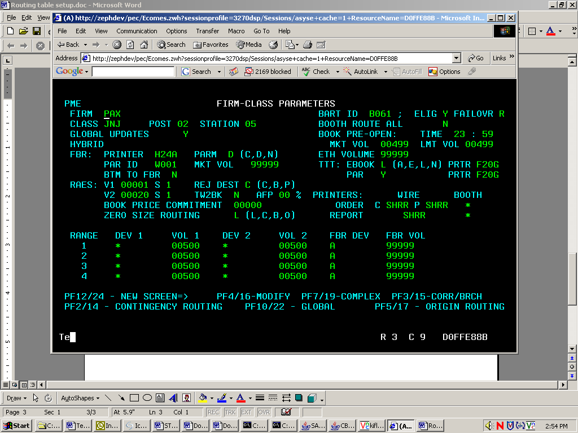

(F2)Contingency Routing Table Setup
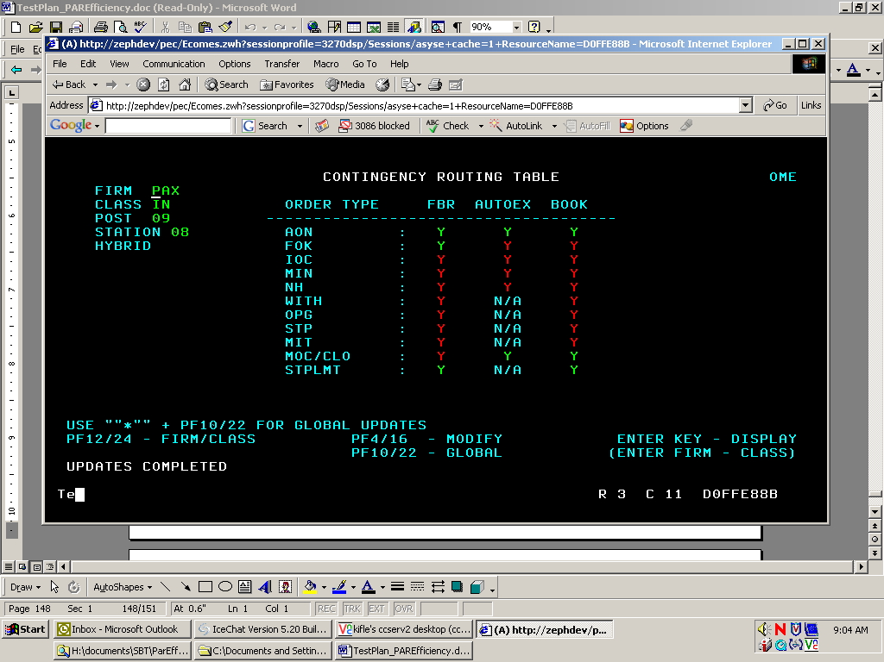
(F5) Simple Order Origin Routing Setup
- Set the ‘D’, ‘F’ & ‘I’, Origin type to route directly to PAR
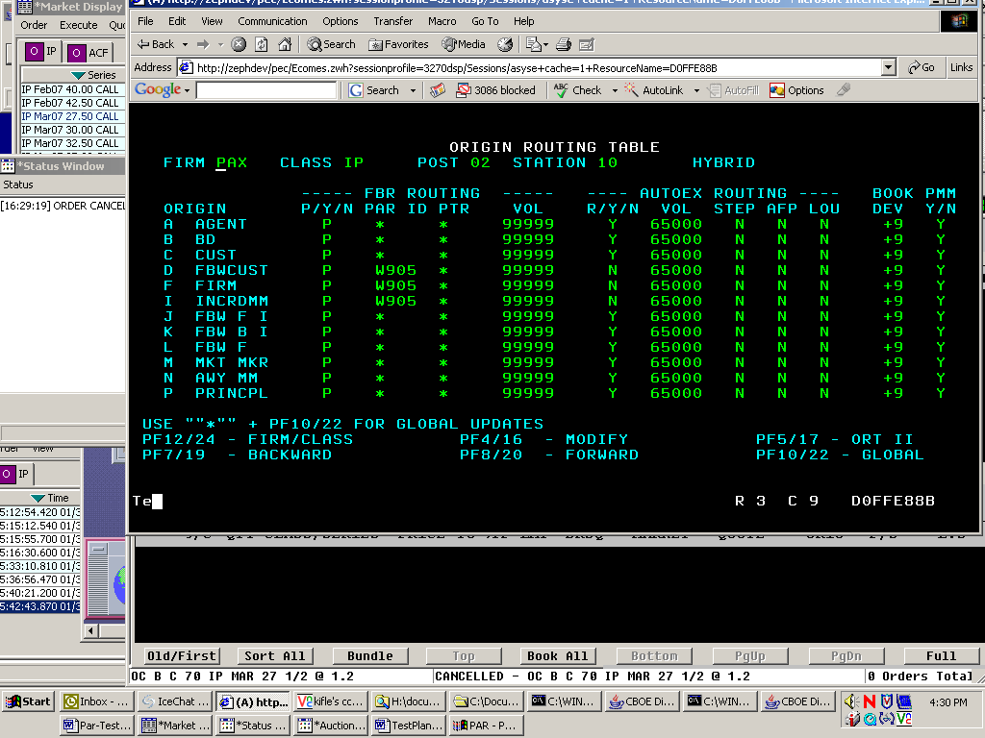

(F5 again) Order Origin Routing Setup (HAL)
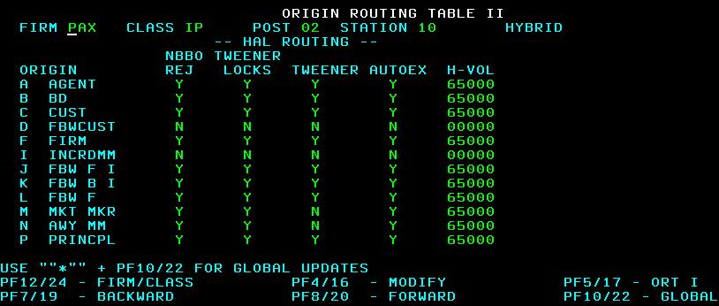

Menu 4 (F7) Complex Order Origin Routing Setup
- Set the ‘D’ & ‘F’ Origin type to route directly to PAR
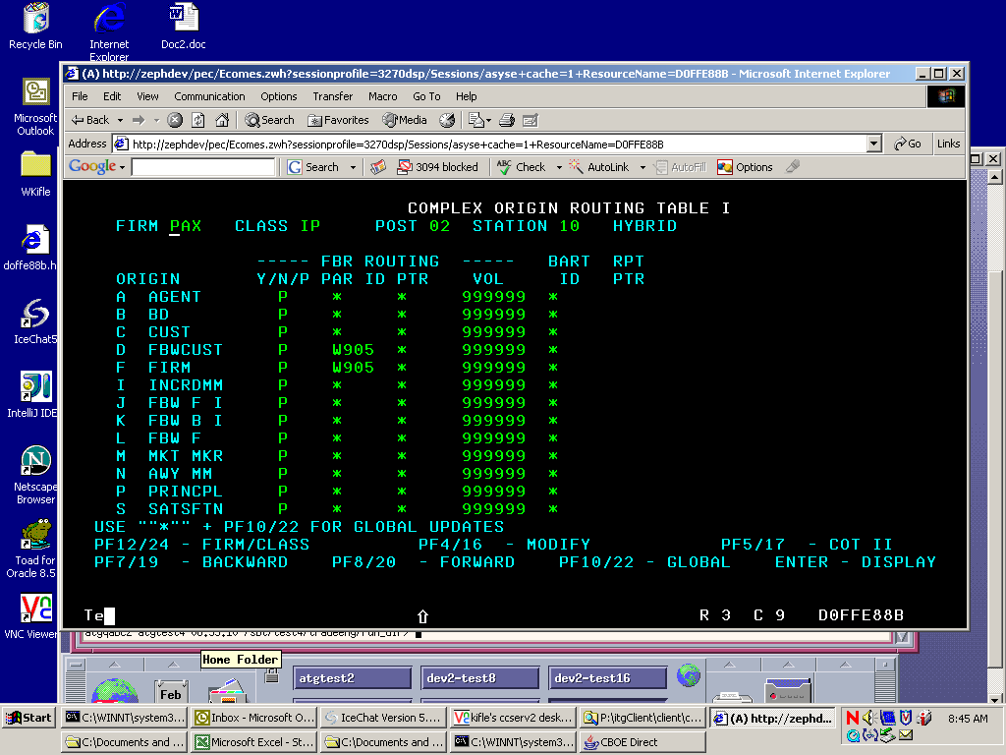

(F5) Complex Order Origin Routing Setup
- Set the ‘F’ Origin type for Auction
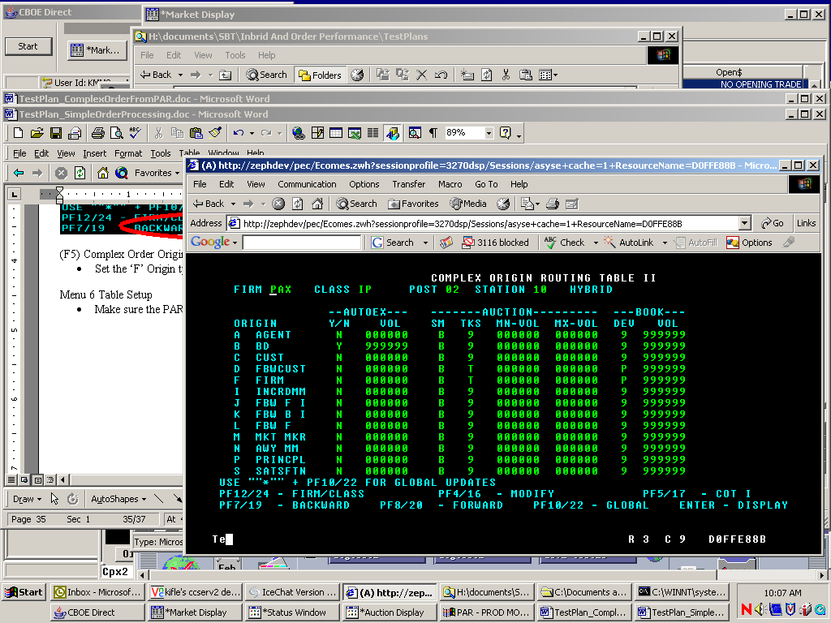
Menu 6 Table Setup
- Make sure the PAR ID matches your par station

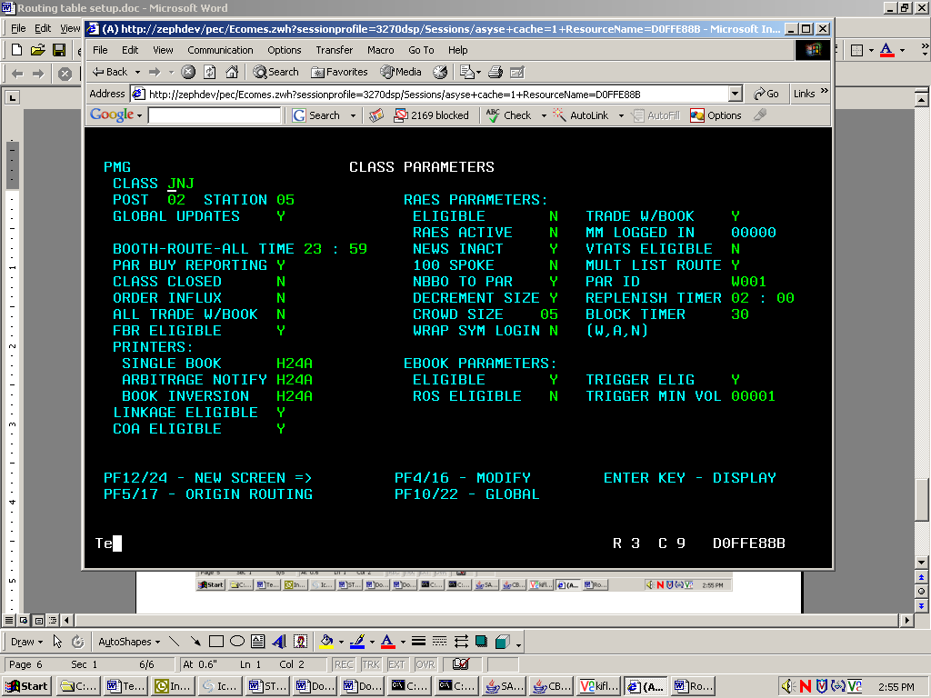
(F5) Class Origin Routing Table Setup
- Set the ‘D’, ‘F’ & ‘I’ Origin type to route directly to PAR

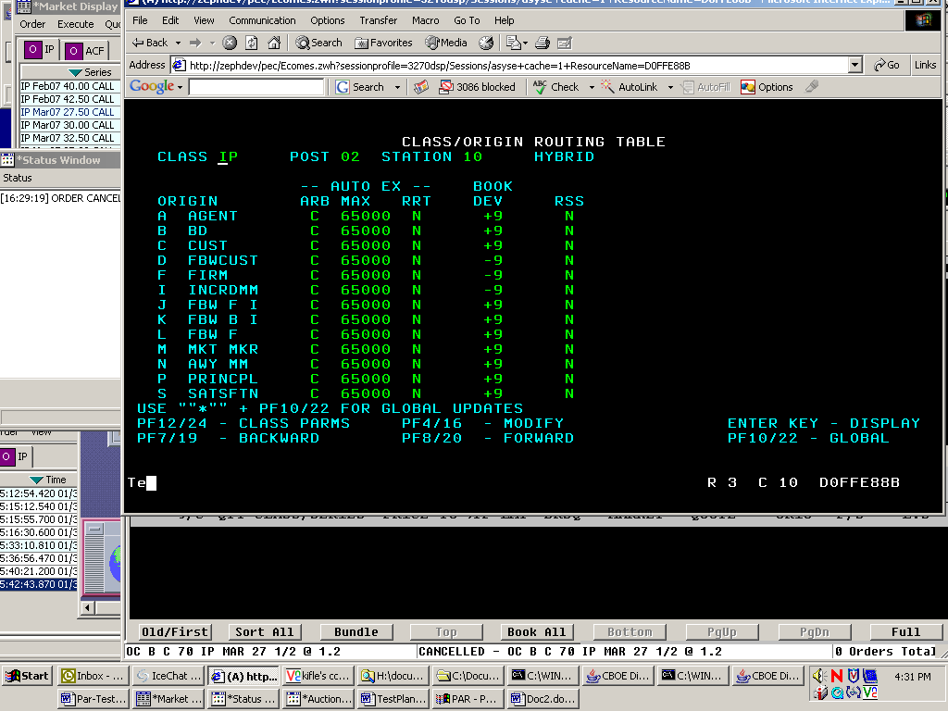

Make sure your class is enabled from TPF for Index Hybrid Processing

From the main Menu, Type in Class <your class symbol>, then Verify that the “Screen Based Trading” is set to ‘I’
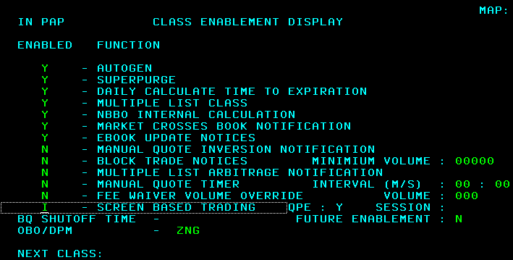

If your class is not enabled for Index Hybrid:

  - Stop Trading – type in “senote” and enter then Esc
  - Clear All Quotes – type in “eauto” and enter then Esc
  - Enable class for Index Hybrid – type in “class <class symbol>” and enter
  - Change the “Screen Based Trading” function from “H” to “I”
  - Start Trading – type in “sstpte” and enter then Esc
  - Start Quote – type on “sauto” and enter

